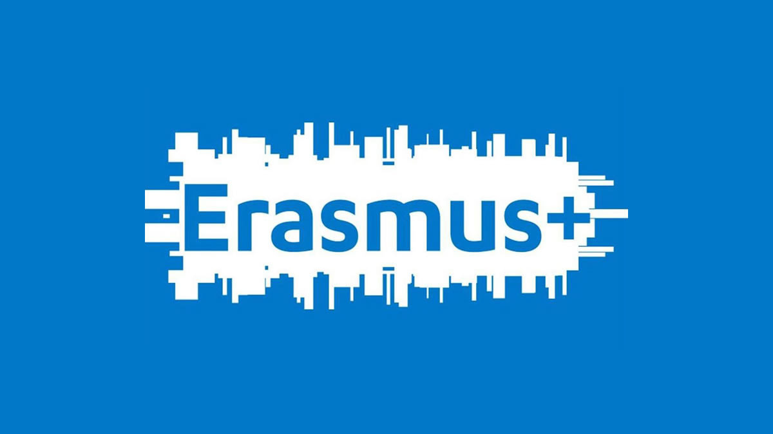 | Here’s your chance for a mobility!

ERASMUS GRANTS
We invite students to submit their applications for Erasmus grants for the summer semester of 2021/22.
OPTION 1: Fachhochschule Südwestfalen, Iserlohn, Germany.
WHO: 2 students of engineering management, or informatics – must have 4 completed semesters
OPTION 2: University PIM, in Banja Luka, Bosnia and Herzegovina.
WHO: 1 student of mechanical engineering or mechatronics – must have 4 completed semesters
WHY: you can spend an Erasmus semester at a university abroad, take all necessary classes there, pass the exams and then have those exams recognized at Subotica Tech, through an automatic exam recognition system.
LANGUAGE: English or German (mobility in Germany) or Serbian (mobility in Bosnia and Herzegovina).
WHEN: Application deadline: November 11, 2021
- Necessary documentation in English: Application form
- CV (Curriculum Vitae)
- Motivation
- Letter Letter of Reference
- Consent form for personal data usage

https://www.vts.su.ac.rs/mobility-application
Submit your application to slivia@vts.su.ac.rs or mobility@vts.su.ac.rs
Further information: International Office, Livia Szedmina

